(Semester II)

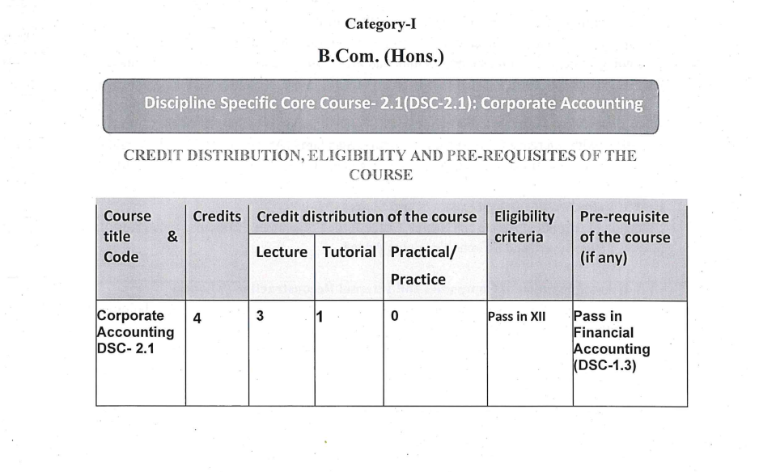
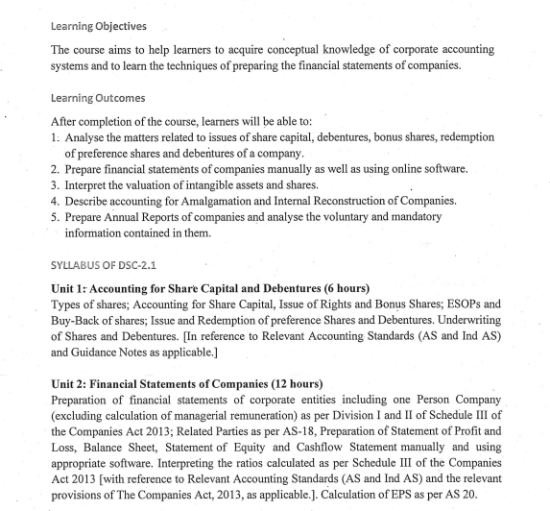
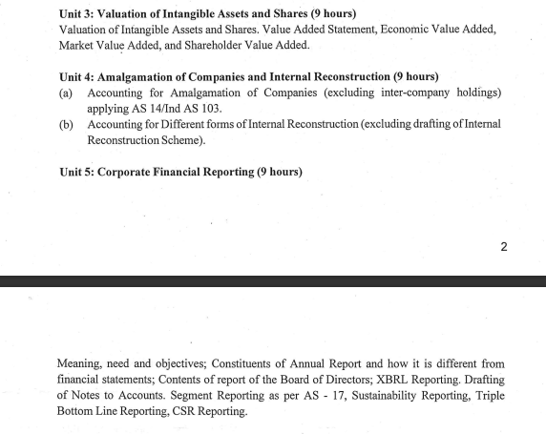
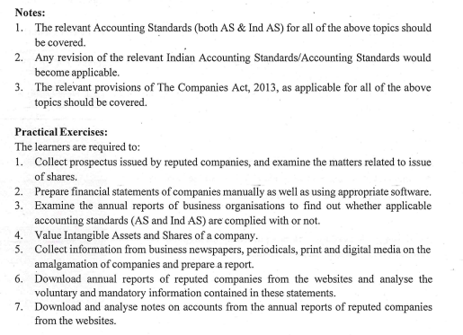
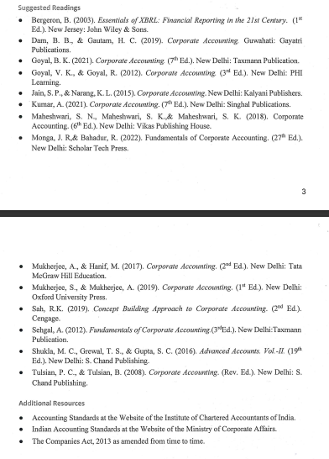

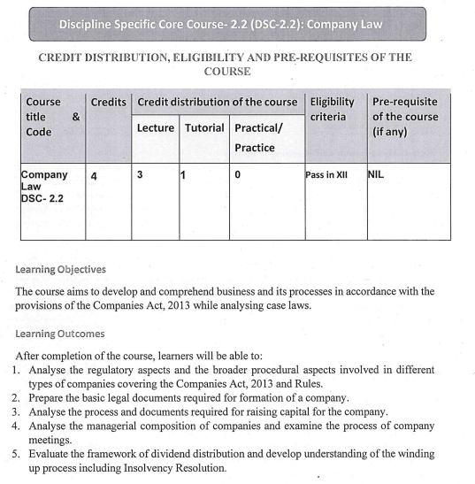
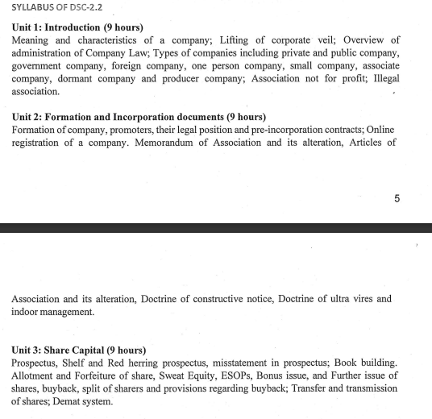
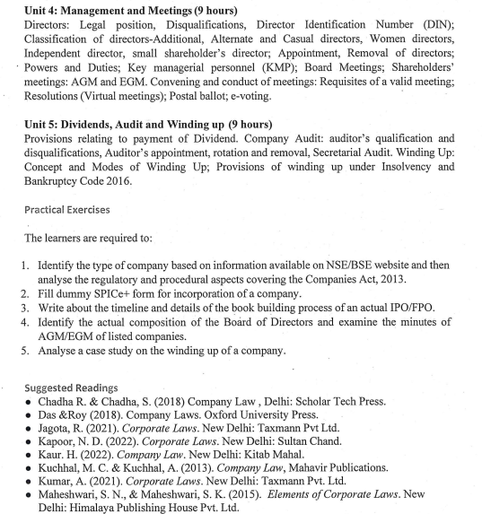
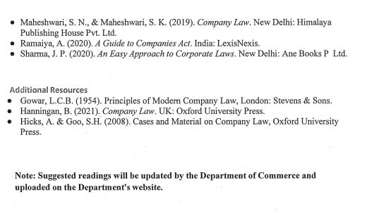

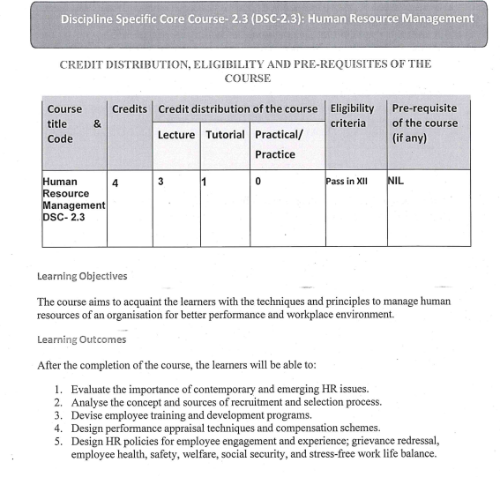
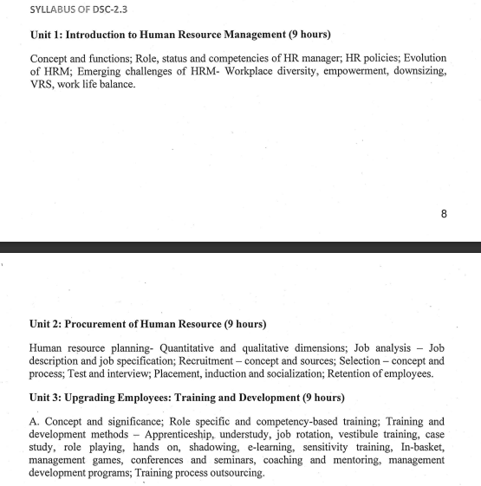
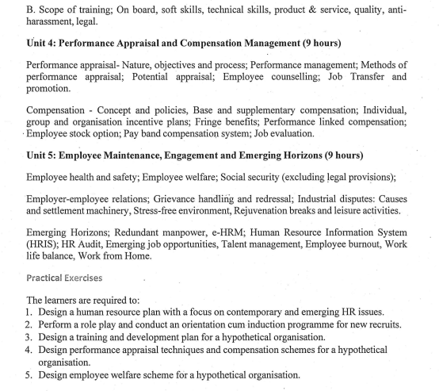
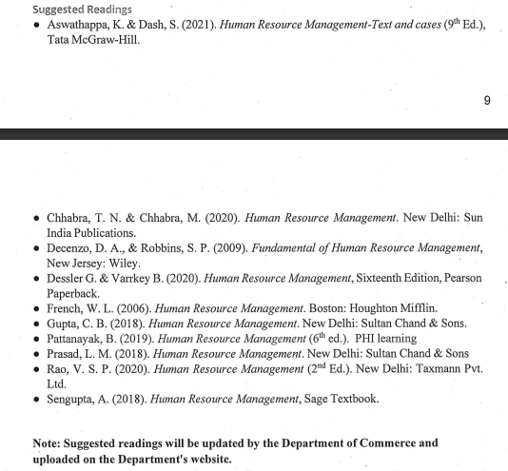

(Semester IV)

- (DSC-4.1): Entrepreneurship & New Venture Planning

Learning Objective:
This course aims at instituting entrepreneurial skills in the students by giving an overview of
entrepreneurship and the competencies that are needed to become an entrepreneur. To enable students to
explore and launch entrepreneurial ventures in their own areas of interest.

Learning Outcomes:
After completion of the course, learners will be able to:
1. Describe distinct entrepreneurial traits.
2. Recognise the process and nature of entrepreneurship.
3. Identify the different ways in which entrepreneurs manifest in start-ups.
4. Comprehend the entrepreneurial process for initiating new venture creation.
5. Design strategies for the successful implementation of innovative ideas of new ventures.

SYLLABUS OF DSC-4.1
Unit 1: Introduction (9 hours)
Concept and Definitions Entrepreneurship, Entrepreneurial Mind-set, Traits/Qualities of Entrepreneurs,
Entrepreneurship process; Theories of entrepreneurship; Factors affecting the emergence of
entrepreneurship; Role of an entrepreneur in economic growth as an innovator; Generation of employment
opportunities; complementing and supplementing economic growth; Bringing about social stability and
balanced regional development of industries.
Discipline Specific Core Course- 4.1(DSC-4.1): Entrepreneurship & New
Venture Planning
111
Unit 2: Types of Entrepreneurs (9 hours)
Classification and Types of Entrepreneurs; Women Entrepreneurs; Social Entrepreneurship; Corporate
Entrepreneurs, Family Business: Concept, structure, and kinds of family firms; Culture and evolution of
family firm; Managing Business.
Unit 3: Business plan (9 hours)
Creating Entrepreneurial Venture: Generating Business ideas, Team building, Sources of Innovation,
Creativity, and Entrepreneurship; Challenges in managing innovation; Entrepreneurial strategy and Scaling
up, Business planning process; Drawing business plans; Failure of the business plan.
Unit 4: Mobilizing Resources (9 hours)
Resource Mobilization for entrepreneurship: Resources mobilization, types of resources, Process of
resource mobilization, Arrangement of funds; writing a Funding Proposal, Traditional sources of financing,
Venture capital, Angel investors, Business Incubators.
Unit 5: Managerial Aspects of Business and Government Initiatives (9 hours)
Managing finance; Understanding capital structure; organisation structure and management of human
resources of a new enterprise; Marketing-mix; Management of cash; Relationship management; Cost
management, Government initiatives for promoting entrepreneurship.

Exercises:
The learners are required to:
1. Discuss various cases of entrepreneurship and distinguish between different entrepreneurial
traits.
2. Prepare a business plan for a start-up venture in a rural setting after analyzing the various
facets of the rural economy.
3. Analyse and present the key initiatives of the government of india for promoting
entrepreneurship in the country in a business area.
4. Analyse and interpret case study on business philosophy at Tata Group, Aditya Birla Group,
Reliance Industries Limited, and similar organisations.
5. Participate in business plan competition-designing a business plan proposal and identifying
alternative sources of raising finance for the start-ups.

Suggested Readings:
● Barringer, B.R., & Ireland, R.D. (2015). Entrepreneurship. Pearson.
● Gersick, K. E., Davis, J. A., Hampton, M. M., & Lansberg, I. (1997). Generation to generation:
Life cycles of the family business. Boston, United States: Harvard Business School Press.
● Hisrich, R.D., Manimala, M.J., Peters, M.P., & Shepherd, D.A. (2013). Entrepreneurship. Delhi,
India: Tata McGraw Hill.
● Kuratko, D.F., & Rao, T. V. (2012). Entrepreneurship: A South-Asian Perspective .Cengage.
● Shukla, M.B. (2007). Entrepreneurship and Small Business Management. Allahabad, India: Kitab
Mahal Publishers.
● Nicholls, A. (Ed.). (2006). Social entrepreneurship new models of sustainable social change.
London: United Kingdom: Oxford University Press.
112
● Hishrich, R.D., & Peters, M.P.(2017), Entrepreneurship. Delhi, India: Tata McGraw Hill.
● Scarborough, N. M., Cornwall, J. R., & Zimmerer, T. (2016). Essentials of entrepreneurship and
small business management. Boston, United States: Pearson.
● Shankar, R. (2012). Entrepreneurship Theory and Practice. Delhi, India: Tata McGraw Hill.
Note: Suggested readings will be updated by the Department of Commerce and uploaded on the
Department's website.

- (DSC-4.2): Cost Accounting

Learning Objective:
The course aims to develop understanding among learners about contemporary cost
concepts and rational approach towards cost systems and cost ascertainment. The course also aims to
provide knowledge about various methods of cost determination under specific situations and to acquire
the ability to use information determined through cost accounting for decision making purposes.

Learning Outcomes:
After completion of the course, learners will be able to:
1. Discuss and analyze the different cost concepts.
2. Determine various components of cost of production.
3. Compute unit cost and total cost by preparing a cost statement.
4. Compute employee cost, employee productivity and employee turnover.
5. Determine cost for different industries using job costing, process costing, contract costing and
service costing.

SYLLABUS OF DSC-4.2
Unit 1: Introduction (11 hours )
Meaning, scope, objectives and advantages of cost accounting; Difference between financial and cost
accounting. Cost concepts and classifications, Overview of elements of cost and preparation of Cost
Sheet for manufacturing sector. Role of a cost accountant in an organisation. Cost Accounting
Standards (CAS – 4 on Cost of Production / Acquisition / Supply of Goods / Provision of Services)
and (CAS – 22 on Manufacturing Cost) as amended from time to time.
Discipline Specific Core Course- 4.2(DSC-4.2): Cost Accounting
113
Unit 2: Elements of Cost : Material and Employee Cost (9 hours )
(a) Materials: Accounting and control of purchases, storage and issue of materials. Techniques of
inventory control, Periodic and perpetual systems of maintaining inventory records, an overview
of methods of pricing of materials issues — FIFO, LIFO and Weighted Average price method,
Valuation of materials as per CAS – 6 on Material Cost, Accounting treatment of losses—
Wastage, scrap, spoilage and defectives
(b) Employee (Labour) Cost: Accounting and Control of employee cost. Time-keeping and timebooking. Employee turnover: meaning, methods of measurement and accounting treatment.
Concept and treatment of idle time and overtime. Methods of wage payment and Incentive
schemes- Halsey, Rowan, Taylor’s differential piece wage.
Unit 3: Elements of Cost: Overheads (9 hours )
Classification, allocation, apportionment and absorption of overheads, Under and over- absorption of
overheads; Capacity Levels and Costs; Treatments of certain items in costing like interest and
financing charges, packing expenses, bad debts, research and development costs.
Unit 4: Methods of Costing ( 9 hours )
Job costing, Contract costing, Process costing (including process losses, valuation of work-inprogress). Service costing (only transport)
Unit 5: Cost Accounting Book-Keeping Systems (7 hours )
An overview of integral and non-integral systems; Reconciliation of cost accounting profit with
financial profits.
Notes :
1. Treatment of various items of cost should be as per the relevant cost Accounting
Standards (CAS) issued by Institute of Cost Accountant of India.
- Use of spreadsheet software should be encouraged for the basic calculation.

Exercises:
The learners are required to:
1. Prepare a cost statement for manufacturing and/ or service organisation.
2. Identify the items to be included and excluded in the material and labour costs.
3. Visit a factory and analyse different elements of overhead costs.
4. Visit industries to understand process costing and prepare a cost statement for any
5. Processindustry.
6. Suggest a suitable cost system for different types of services organisation.

Suggested Readings:
● Arora, M.N. (2021). Cost Accounting-principles and practice. Delhi, India: Vikas
Publishing House.
● Goel, R. K., & Goel, I. (2019). Concept Building Approach to Cost Accounting for B.Com
(Hons.)/B.Com. Delhi, India: Cengage Publications.
● Gupta, S., R., & Prabhakar, R. R. (2021).Cost Accounting for B.Com. Delhi, India: Sultan Chand.
● Maheshwari, S. N., & Mittal, S. N. (2020). Cost Accounting. Theory and Problems. Delhi, India:
114
Shri Mahaveer Book Depot.
● Maheshwari, S. N., Mittal S. K., & Mittal, S.N. (2021). Cost Accounting: Principles & Practice.
Delhi, India: Shree Mahaveer Book.
● Mitra,J. K. (2021). Cost and Management Accounting. Delhi, India: Oxford University Press.
● Nigam, B. M. L., & Jain, I. C. (2023). Cost Accounting: Principles and Practice. Delhi, India: PHI
Learning.
● Singh, S. (2019). Fundamentals of Cost Accounting. Allahabad, India: Kitab Mahal.
● Tulsian, P.C. (2020). Cost Accounting. Delhi, India: S.Chand.
Additional Resources:
● Drury, C. (2018). Management and Cost Accounting. China: Cengage.
● Horngren, C. T., Foster, G., & Dattar, S. M. (2017).Cost Accounting: A Managerial Emphasis. Delhi,
India: Prentice Hall of India Ltd.
● Jain, S.P., & Narang, K.L. (2021). Cost Accounting: Principles and Methods. Jalandhar, India:
Kalyani Publishers.
Note: Suggested readings will be updated by the Department of Commerce and uploaded on the
Department's website.

- (DSC-4.3): International Business

Learning Objectives:
The course aims to impart the core body of knowledge in international business to the students. The course
would introduce students to the international trading and investment environment and also create awareness
about emerging issues such as outsourcing and sustainable development in the context of international
business.

Learning Outcomes:
After completion of the course, learners will be able to:
Discipline Specific Core Course- 4.3 (DSC-4.3): International Business
115
1. Analyse the process of globalization and its impact on growth of international business.
2. Evaluate the changing dynamics of the diverse international business environment.
3. Analyse the theoretical dimensions of international trade as well as intervention measures adopted.
4. Analyse the significance of different forms of regional economic integration and the role played by
various international economic organisations.
5. Evaluate the forms of foreign direct investment and analyse benefits and costs of FDI.

SYLLABUS OF DSC-4.3
Unit 1: Introduction to International Business (7 hours)
Globalization - concept, significance and impact on international business; international business contrasted
with domestic business; complexities of international business; internationalization stages and orientations;
modes of entry into international businesses.
Unit 2: International Business Environment (11 hours)
Role of political and legal systems in international business; cultural environment of international business;
implications of economic environment for international business.
Unit 3: International Trade (9 hours)
Theories of international trade – Theory of Absolute Advantage theory, Theory of Comparative Advantage,
Factory Proportions theory and Leontief paradox, Product Life Cycle theory, Theory of National
Competitive Advantage; Instruments of trade control.
Unit 4: Regional Economic Integration and International Economic Organisations (9 hours)
Forms of regional economic integration; Integration efforts amongst countries in Europe, North America
and Asia: EU, USMCA, and SAARC; Cost and benefits of regional economic integration.
International Economic Organisations: WTO- functions, structure and scope; World Bank and IMF
Unit 5: International finance and contemporary issues in IB (9 hours)
Types of FDI - Greenfield investment, Mergers & Acquisition, strategic alliances; benefits and drawbacks
of FDI
Overview of Exchange Rate systems
Contemporary issues in international business: Outsourcing and its potential for India; international
business and sustainable development.

Exercises:
The learners are required to:
1. Demonstrate through case studies the suitability of each mode of entry in international business.
2. Conduct a comparative analysis of countries which are different in terms of
political/legal/economic/cultural environment to understand the impact of these dimensions on
international business.
3. Analyse data on trade of select countries to examine if trade patterns conform to different trade
theories.
4. Conduct an in-depth study of a regional economic arrangement and evaluate its costs and benefits
by applying the theoretical knowledge gained during the course
5. Make presentations on developments in contemporary issues affecting international business such
as sustainable development.
116

Suggested Readings:
● Bennett, R. (2006). International Business. Delhi, India: Pearson.
● Cavusgil, S. T., Knight, G., & Riesenberger, J. (2006). International Business: Strategy,
Management and the New Realities. India: Pearson India.
● Hill, C.W.L., & Jain, A. K. (2011). International Business. Delhi, India: Tata McGraw
Hill.
● Chaturvedi, D.D., Jindal, D., & Kaur, R. (2022). International Business. Delhi, India:
Scholar Tech Press.
● Daniels, J. D., Radenbaugh, L. H., & Sullivan, D. P. (2016). International Business.
Pearson Education.
● Griffin, R. W., & Pustay, M. W. (2014). International Business - A Managerial
Perspective. New Jersey, United States: Prentice Hall.
● Joshi, R.M. (2009). International Business. Delhi, India: Oxford University Press.
● Menipaz, E., Menipaz A., & Tripathi S.S. (2017). International Business: Theory and
Practice. Delhi, India: Sage Publications India Pvt. Ltd.
Additional Resources
● Economic Survey, various issues.
● RBI Report on Currency & Finance, various issues.
● World Investment Reports, UNCTAD
● Websites: RBI, IMF, WORLD BANK, WTO.
● WTO Annual reports
Note: Suggested readings will be updated by the Department of Commerce and uploaded on the
Department's website.

(Semester VI)

- Paper BC 6.1 (e): FINANCIAL MARKETS, INSTITUTIONS AND SERVICES

Duration: 3 Hours Marks: 100 Credits: 6
Course Objective
To provide students an overview of financial markets & institutions in India and
familiarize them with important fee and fund based financial services.
Course Learning Outcomes
After completing the course, the student shall be able to:
CO1 – understand the meaning and scope of Financial Markets as well as institutions in
India.
CO2 – familiarize the students with the concepts of Money Market and Capital Market.
CO3 - explain Commercial Banking and its Current developments.
CO4 - familiarize the students with the concept of Non-Banking Financial Companies
(NBFC’s).
CO5 - examine the Financial Services Industry.
Course Contents
Unit-I: Introduction to Financial System
An Introduction to Financial System, Components, Financial System and Economic
Development, Financial intermediation, An overview of Indian financial system since
1951, Financial Sector Reforms since liberalization 1990-91.
Unit-II: Financial Markets & Capital Markets
Financial Markets: Money Market – functions, organisation and instruments. Role of
central bank in money market. Indian Money Market – an overview. Capital Markets –
Introduction, role and functions. Components of Capital market. Cash markets- Equity
and Debt, Depository (NSDL, CDSL). Primary and Secondary Markets –NSE, BSE,
NIFTY, SENSEX. Role of Stock Exchanges in India. SEBI and Investor Protection. An
overview of Global financial markets: NYSE, NASDAQ, Dow Jones, Federal Reserve
Bank, Bank of England, Bank of Japan, European Central Bank.
Unit-III: Financial Institutions I
Financial Institutions: Commercial banking – introduction, classification, its role in
financing-commercial and consumer, recent developments like MUDRA financing,
problem of NPAs, Bankruptcy and Insolvency Act, Financial Inclusion.
Unit IV: Financial Institutions II
Life and non-life insurance companies in India: public and private. Mutual Funds –
Introduction and their role in capital market development. Types of mutual fund schemes
B.Com CBCS Department of Commerce, University of Delhi
76
(open ended vs close ended, Equity, Debt, Hybrid schemes and ETFs. Non-banking
financial companies (NBFCs).
Unit-V: Financial Services Industry
Overview of financial services industry. Merchant banking – Pre and Post issue
management, underwriting. Regulatory framework relating to merchant banking in India.
Consumer and Housing finance, Venture Capital Finance, Credit Rating.
References
• Bhole, L.M., et. al. Financial Institutions and Markets . Tata McGraw Hill
Publishing Company.
• Khan,M.Y. and Jain,P.K. Financial Services, Tata McGraw Hill.
• Khan,M.Y. Indian Financial System–Theory and Practice, Vikas Publishing House.
• Kumar, V., Gupta, K., Kaur, M., Financial Markets, Institutions and Financial
Services, Taxmann’s Publications.
Additional Resources
• Annual Reports of Major Financial Institutions in India.
• Bhole, L.M., Financial Markets and Institutions. Tata McGraw Hill Publishing
Company.
• Sharma, G.L., & Singh, Y.P., Contemporary Issues in Finance and Taxation,
Academic Foundation, Delhi

- Paper BC 6.2 (b): FUNDAMENTALS OF INVESTMENT

Duration: 3 Hrs. Marks: 100 Credits: 6
Course Objective
To familiarize the students with different investment alternatives, introduce them to the
basics of their analysis, valuation and investor protection.
Course Learning Outcomes
After completing the course, the student shall be able to:
CO1 – acquaint with the Investment Environment and concept of Return & Risk.
CO2 – develop the understanding of Bond valuation & role of Credit Rating agencies.
CO3 – understand the methods of Equity analysis approaches.
CO4 – analyze two securities portfolio using Harry Markowitz model and CAPM, Mutual
Funds and Financial derivatives.
CO5 – examine investors’ protection framework.
Course Contents
Unit-I: The Investment Environment The investment decision process. Types of Investment-Commodities, Real Estate and
Financial Assets. The Indian securities market, the market participants and trading of
securities, security market indices, sources of financial information. Return and Risk:
Concept, Calculation, Trade off between return and risk, Impact of taxes and inflation on
return.
Unit-II: Fixed Income Securities Bond Fundamentals, Estimating bond yields, Bond Valuation, Types of bond risks.
Default risk and credit rating.
Unit-III: Approaches to Equity Analysis Fundamental Analysis, Technical Analysis and Efficient Market Hypothesis. Valuation of
Equity Shares.
Unit-IV: Portfolio Analysis and Financial Derivatives Two securities Harry Markowitz Model of Portfolio Analysis and Diversification.
CAPM, Portfolio Risk and Return, Mutual Funds, overview of Financial DerivativesForwards, Futures & Options.
Unit-V: Investor Protection Role of SEBI and stock exchanges in investor protection; Investor grievances and their
redressal system, insider trading, investors’ education and awareness.
References
• Mayo, An Introduction to Investment. Cengage Learning.
B.Com CBCS Department of Commerce, University of Delhi
81
• Rustagi, R.P., Investment management. Sultan Chand, New Delhi.
• Singh, Y.P., Fundamentals of Investment management. Galgotia Publications.
• Tripathi, Vanita, Fundamentals of Investments. Taxmann.
Additional Resources
• Jones, C.P., Investment Analysis and Management. Wiley.
• Videos of Eugene Fama on the history of Finance.
• Vohra, N.D., and Bagri, Future and Options. McGraw Hill Publishing

- Paper BC 6.3 (a): ADVERTISING, PERSONAL SELLING AND
SALESMANSHIP

Duration: 3 Hrs. Marks: 100 Credits: 4

Course Objective
The objective of this course is to provide knowledge concerning advertising and personal
selling and to equip them with the skill to use these promotion tools.
Course Learning Outcomes
After completing the course, the student shall be able to:
C01: understand the communication objectives behind advertising and promotions.
C02: understand the various message and media elements in the advertising decisions.
CO3:analyse the effectiveness of advertising.
CO4:comprehend the importance and role of personal selling.
C05: understand the process of personal selling.
Course Contents
Unit I: Introduction to Advertising
Communication Process; AIDA Model, Advertising: Importance, types and objectives;
DAGMAR Approach; Audience Selection; Methods of setting Advertising Budget.
Unit II: Message and Media Decisions
Advertising Appeals; Advertising Copy: Elements of print and broadcast advertising
copy; Types of Media: Merits and Demerits; Media Scheduling.
Unit III: Advertising Effectiveness
Advertising Agency: Role and types. Evaluating Communication and Sales Effect; Pre
and Post-testing Techniques.
Unit IV: Introduction to Personal Selling and Salesmanship
Concept of Personal Selling and Salesmanship; Personal Selling Situations; Qualities of a
Good Salesperson; Types of Salespersons; Role of Personal Selling in CRM; Career
Opportunities in Selling; Measures for making selling as an attractive career; Buying
Motives.
Unit V: Personal Selling Process

Prospecting; Pre Approach; Approach; Presentation and Demonstration; Handling of
Objections; Closing the Sale; Follow-Up.
B.Com CBCS Department of Commerce, University of Delhi
88
Note: All units would be having an application oriented component.
References
• Buskirk, R. A. B. D. Buskirk, F. A. Russell (1988), Selling: Principles and Practices,
McGraw-Hill.
• Futrell, Charles (2013), Fundamentals of Selling, McGraw Hill Education
• Gupta, Ruchi (2017), Advertising, Scholar Tech Press.
• Sharma, Kavita (2018), Advertising: Planning and Decision Making, Taxmann
Publication Pvt. Ltd.
Additional Resources
• Belch, G. E., M. A. Belch and Purani K. (2009), Advertising and Promotion: An
Integrated Marketing Communications Perspective, McGraw Hill Education.
• Castleberry, S.B. and Tanner, J. F. (2013), Selling: Building Relationships, McGraw
Hill Education.
• IBS Case Study Centre, www. ibscdc.org
• Kapoor, Neeru (2008), Advertising and Personal Selling, Pinnacle.
• Shah, Kruti and A. D’Souza (2008), Advertising and Promotions: An
IMC Perspective, McGraw Hill Education.

- Paper BC 6.4 (a): ENTREPRENEURSHIP DEVELOPMENT

Duration: 3 Hrs. Marks: 100 Credits : 6
Course Objective
This course aims at imparting of basic knowledge on entrepreneurship and new enterprise
creation so that it provides an opportunity for the students to opt entrepreneurship as an
alternative career option.
Course Learning Outcomes
After completing the course, the student shall be able to:
CO1: understand entrepreneurship as volition in context of India.
CO2: gather knowledge and ideas on the existing support system for entrepreneurial
orientation.
CO3: understand enterprise formation process for gaining ideas as to creation of an
enterprise for pursuing a career.
CO4: understand of requirement of post-enterprise creation for effective operation of the
business.
CO5: gain knowledge on available growth strategies for implementing effective suitable
strategy for expansion and growth.
Course Contents
Unit I: Introduction
Entrepreneurship- meaning importance and determinants; Entrepreneurship as a dynamic
response to societal issues; Entrepreneurship in Indian scenario as a career option;
Understanding intrapreneurship, techno-entrepreneurship, net-entrepreneurship, ecoentrepreneurship, and social entrepreneurship.
Unit II: Entrepreneurial Eco-System
Socio-economic support system for entrepreneurship; Public and private system of
stimulation; Role of Development Institutes, availability of finance, marketing,
technology and project related assistance, role of trade associations and self-help groups
for promotion of entrepreneurship; Types of business entities-micro, small and medium
enterprises, role of MSME sector in Indian economy; Nature and characteristics of family
businesses in India; Startup Action Plan; Make in India initiative.
Unit III: Enterprise Formation Process
Understanding and analyzing business opportunities; Market demand analysis,
preparation of business plan, project feasibility study; Start ups and basic start ups
problems; Cases of Indian start ups, Sources of financing business start ups (practical
knowledge on preparation of business plan/project report shall be taught in the class).
Unit IV: Managerial Aspects of Business
B.Com CBCS Department of Commerce, University of Delhi
101
Managing finance- preparation of operating/cost budget, cash budget; Understanding
management of short term and long term capital; Human Resource planning; Contract
management; Understanding marketing methods; Understanding of GST and other Tax
compliances.
Unit V: Managing Growth
Business growth strategies specific to small enterprises; Enterprise life cycle and various
growth strategies; Business collaboration and outsourcing of resources; Network
management, succession planning for sustenance; Managing family business and its
conflicts.
References
• Brandt, S. C. Entrepreneuring: The Ten Commandments for Building a Growth
Company. MacMillan Business Books.
• Panda, S. C. Entrepreneurship Development. New Delhi: Anmol Publications.
• Taneja, S., & Gupta, S. L. Entrepreneurship Development-New Venture creation.
New Delhi: Galgotia Publishing House.
• Vasper, K. H. New Venture Strategies (Revised Edition ed.). New Jersey: Prentice
Hall.
Additional Resources
• Dollinger, M. J. Entrepreneurship: Strategies and Resources. Illinois: Irwin.
• Holt, D. H. Entrepreneurship: New Venture Creation. New Delhi: Prentice Hall of
India.

